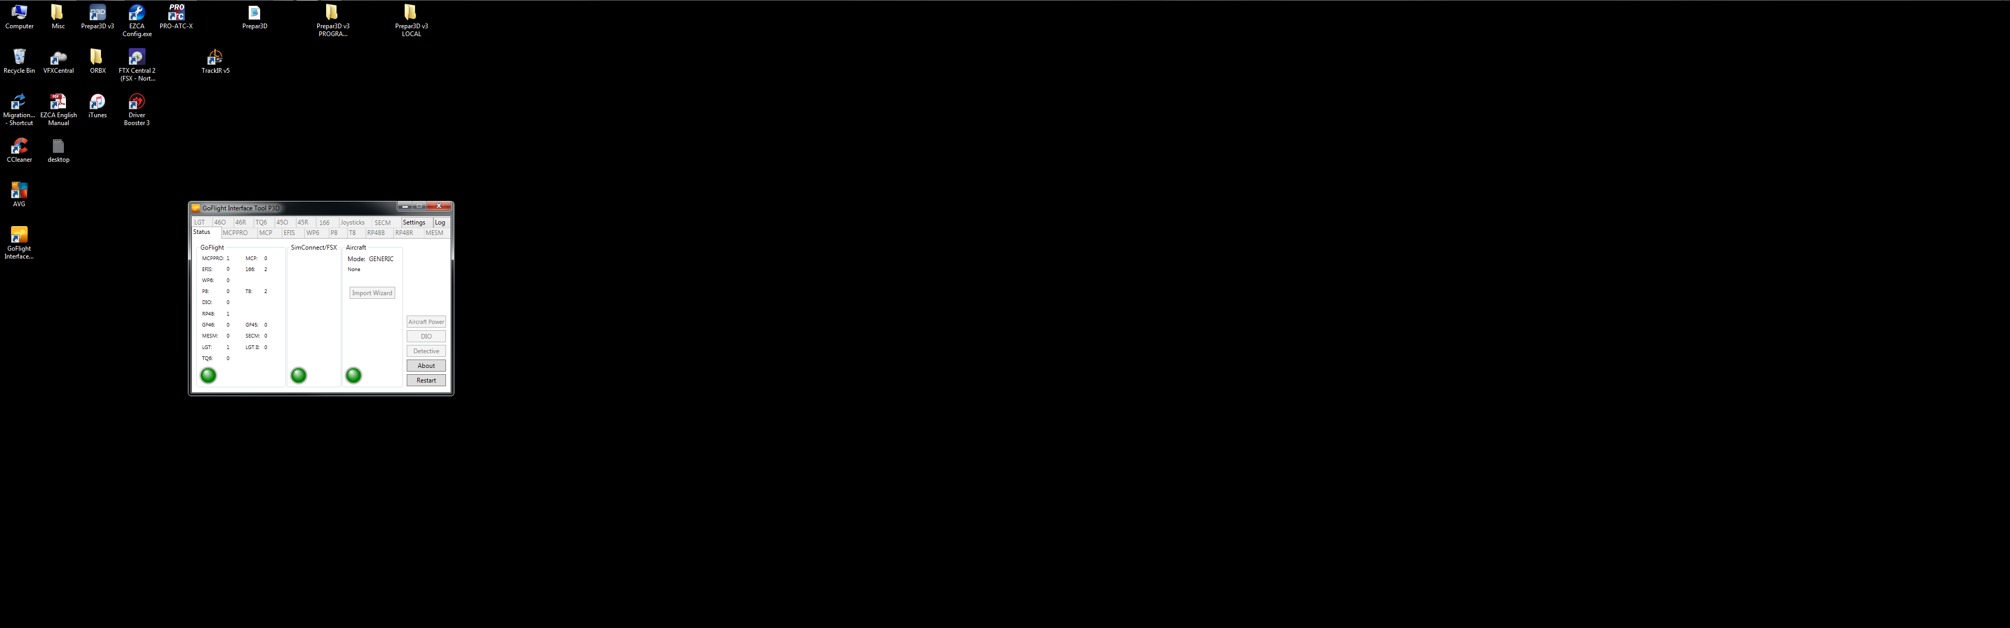

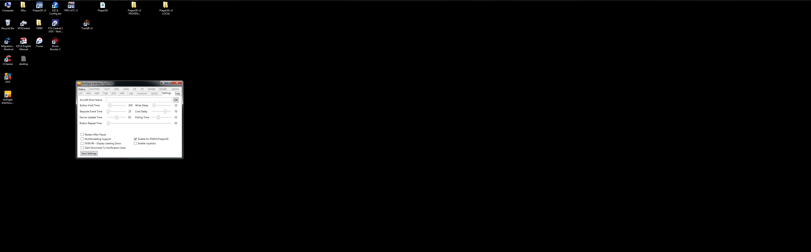

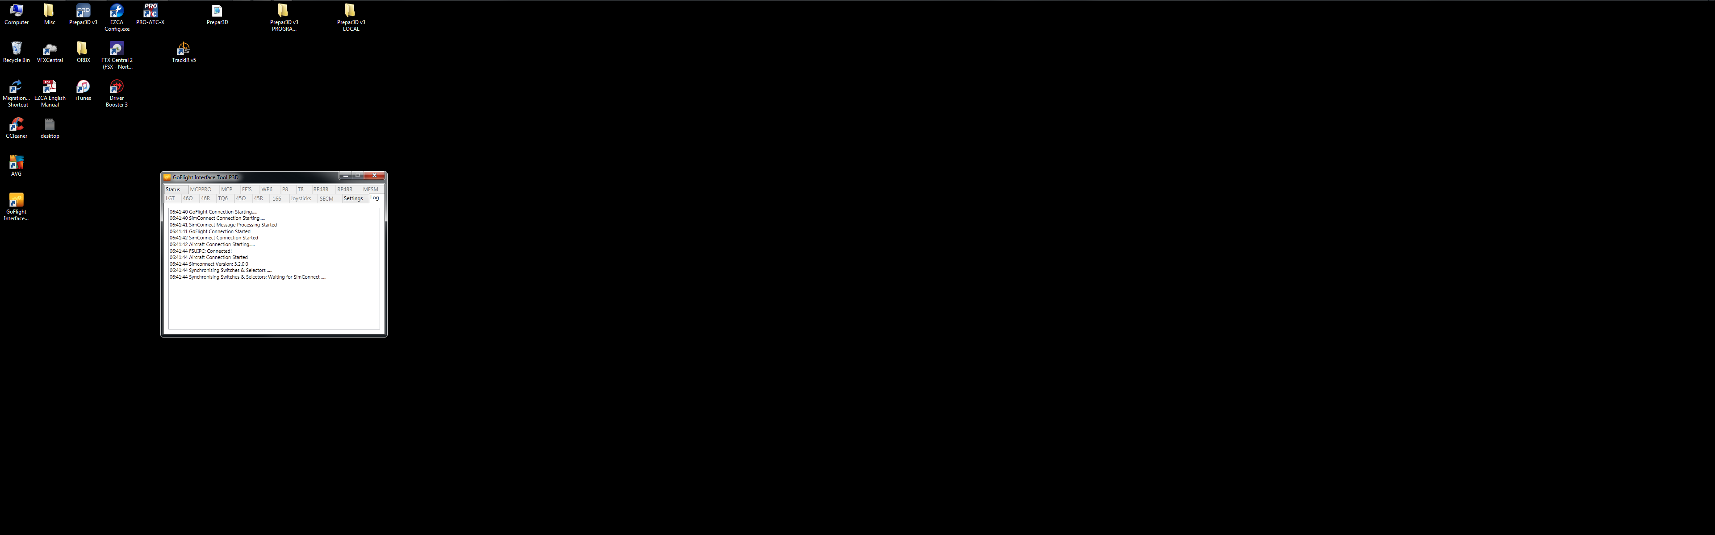

06:41:40 GoFlight Connection Starting.....

06:41:40 SimConnect Connection Starting.....

06:41:41 SimConnect Message Processing Started

06:41:41 GoFlight Connection Started

06:41:42 SimConnect Connection Started

06:41:42 Aircraft Connection Starting.....

06:41:44 FSUIPC: Connected!

06:41:44 Aircraft Connection Started

06:41:44 Simconnect Version: 3.2.0.0

06:41:44 Synchronising Switches & Selectors .....

06:41:44 Synchronising Switches & Selectors: Waiting for SimConnect .....

